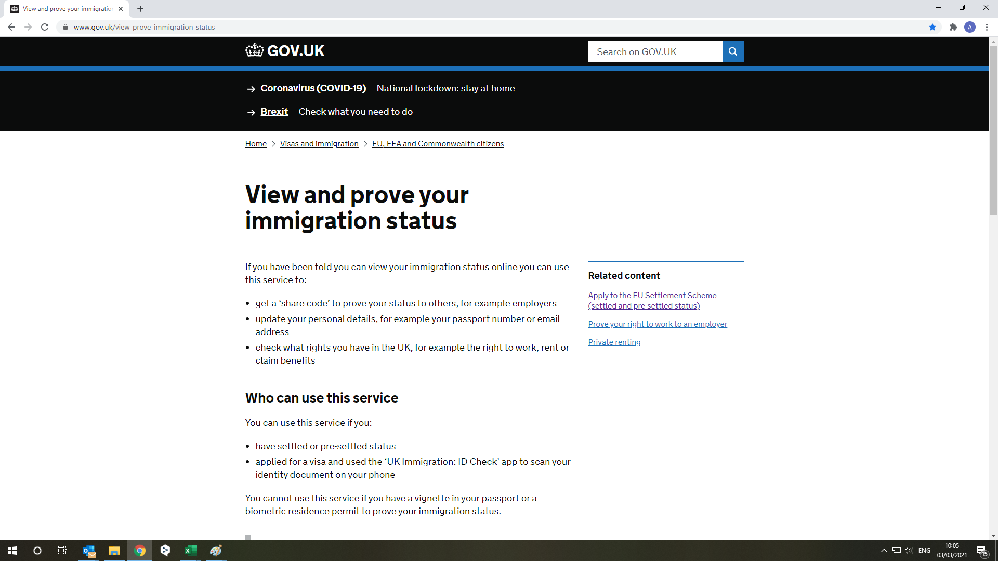

Press this button.

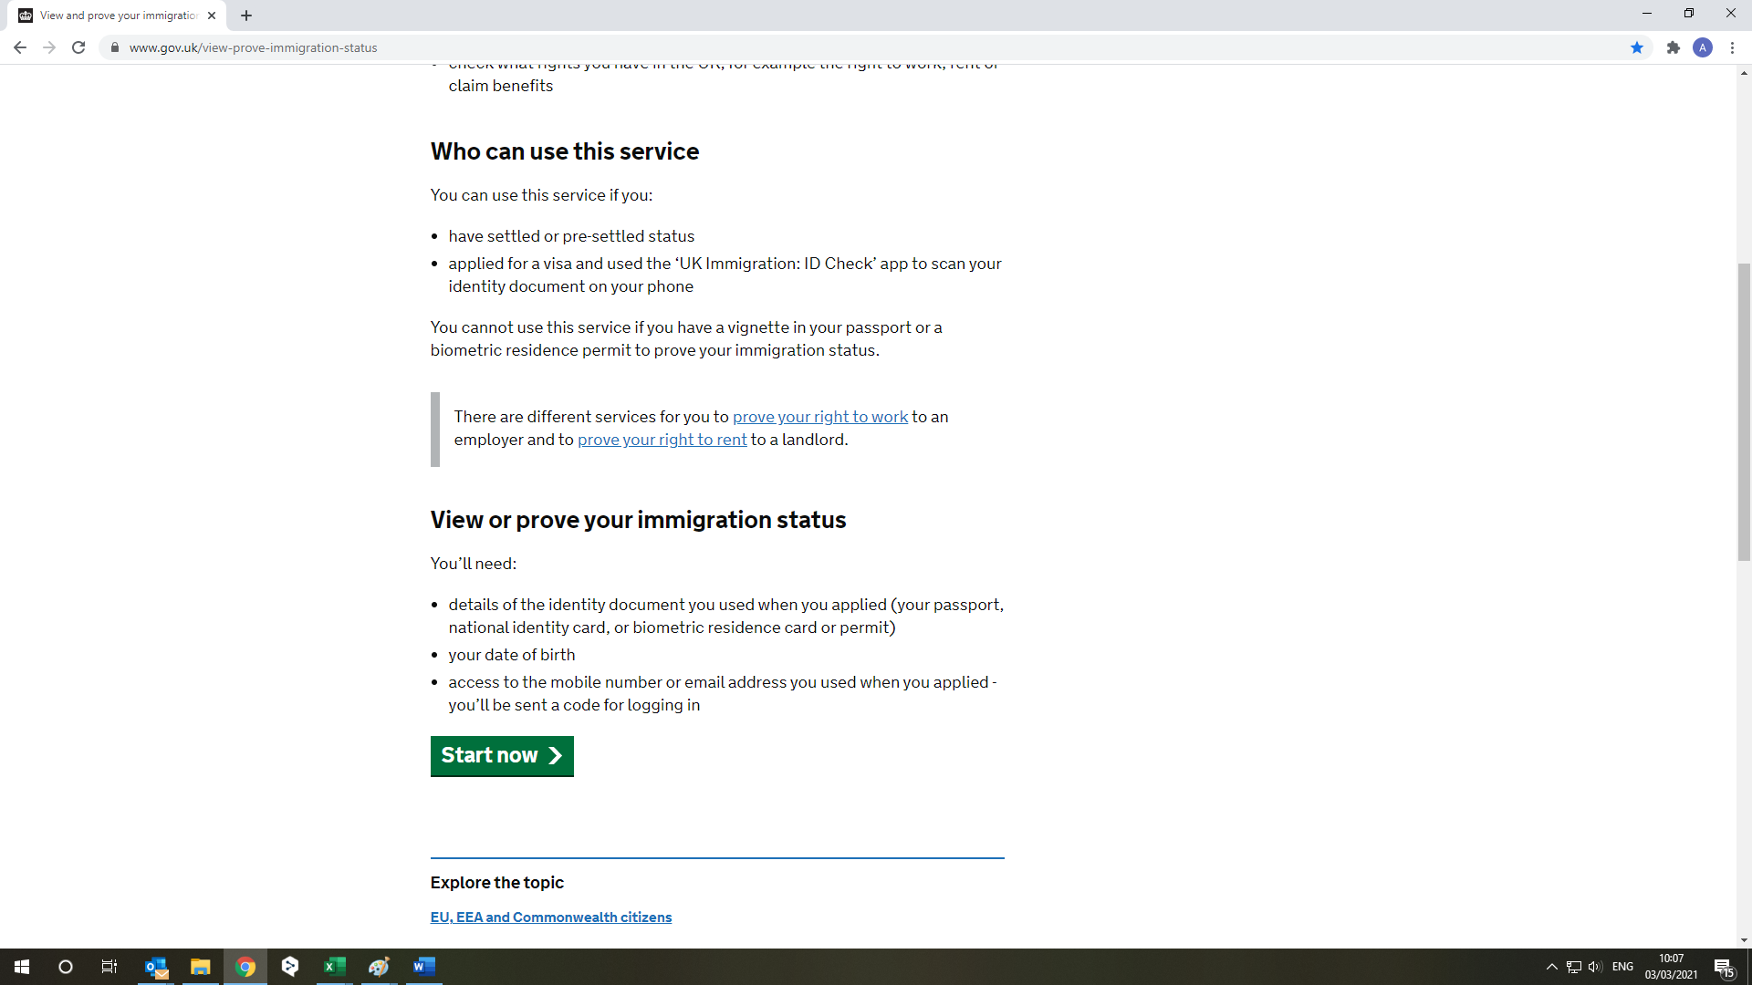 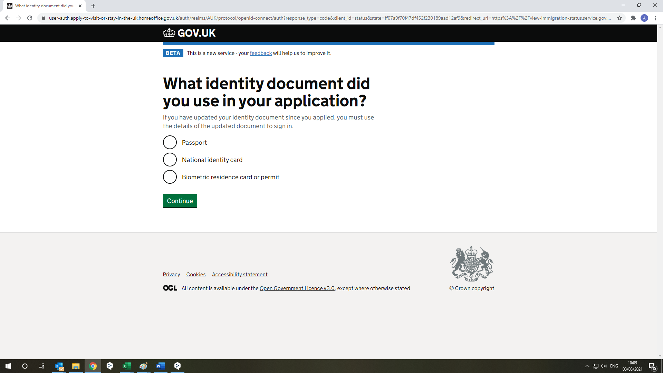

Press this button

Select your document.

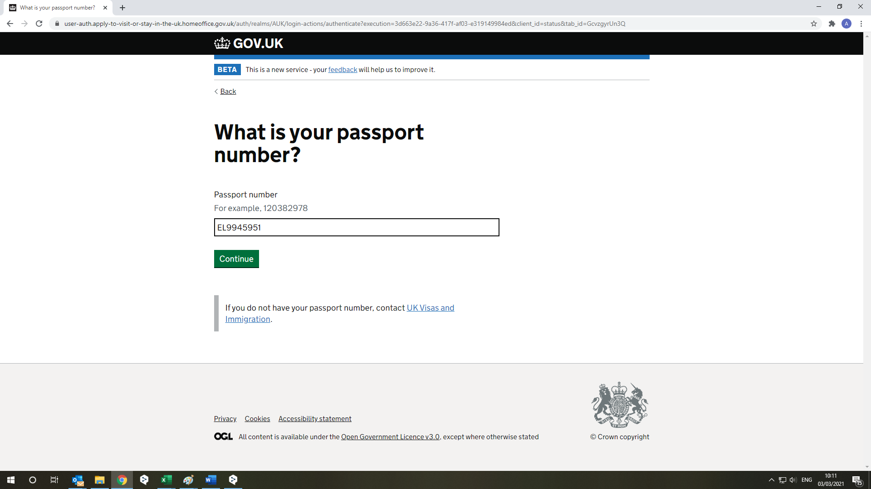

Enter the number of document chosen by you, for example number passport

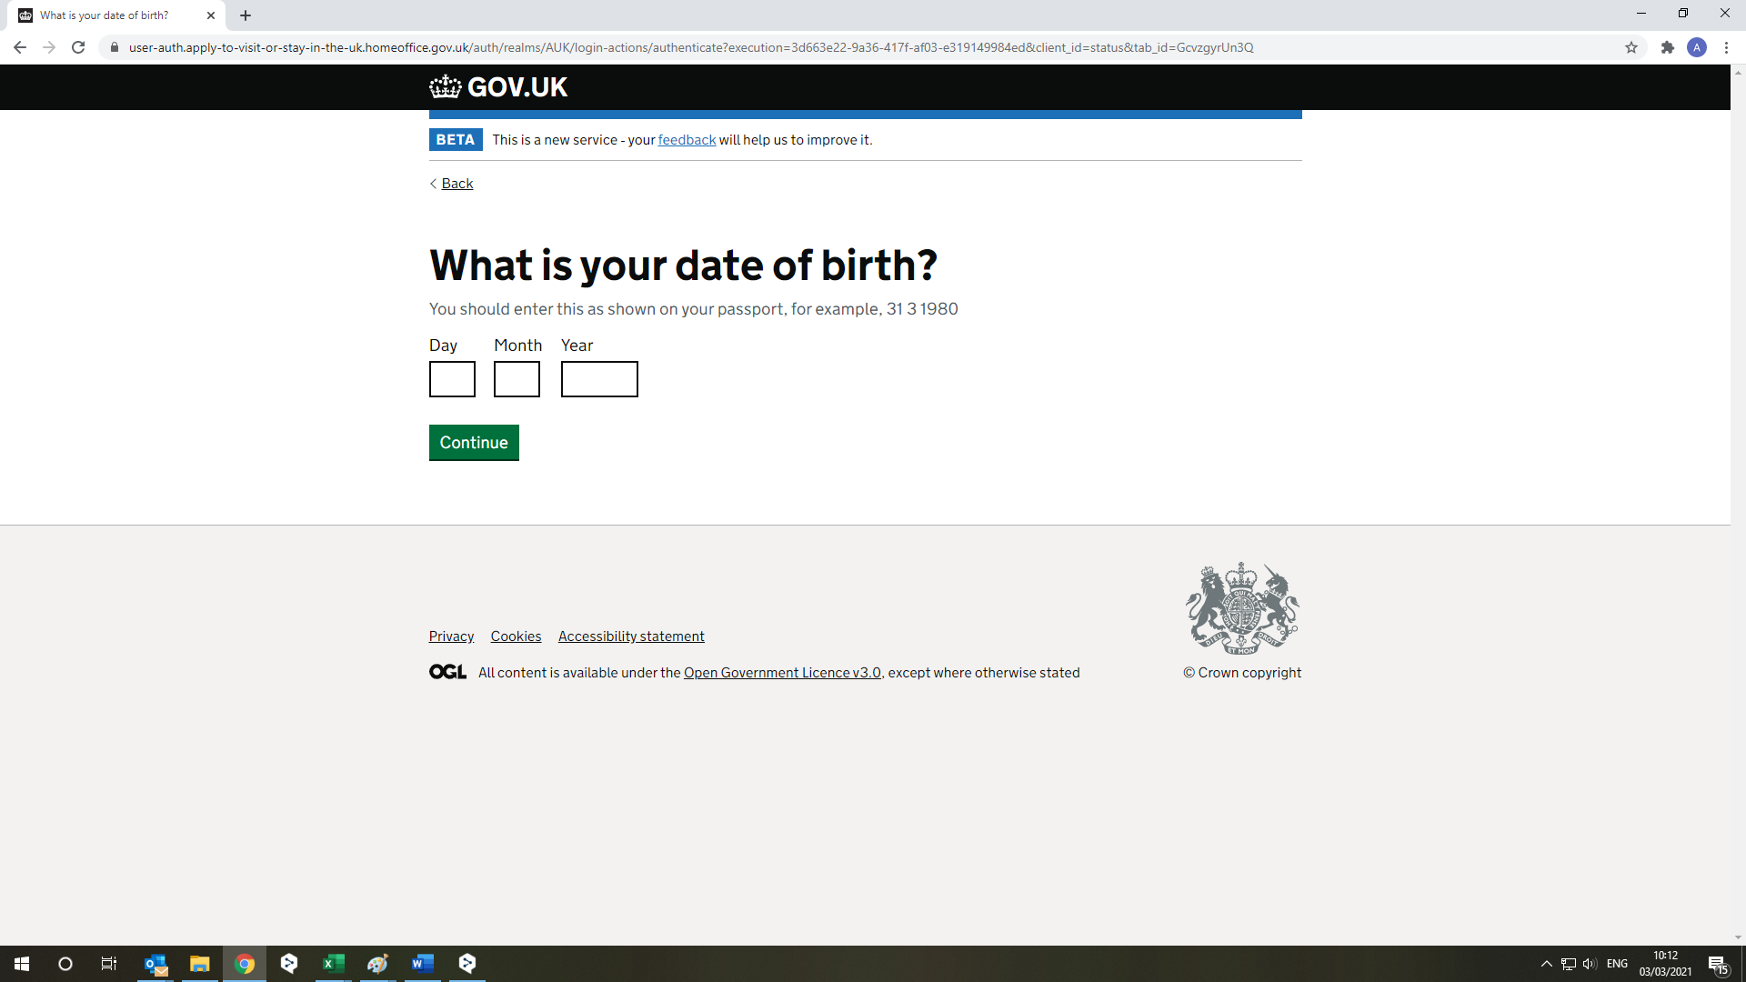

Please complete this area

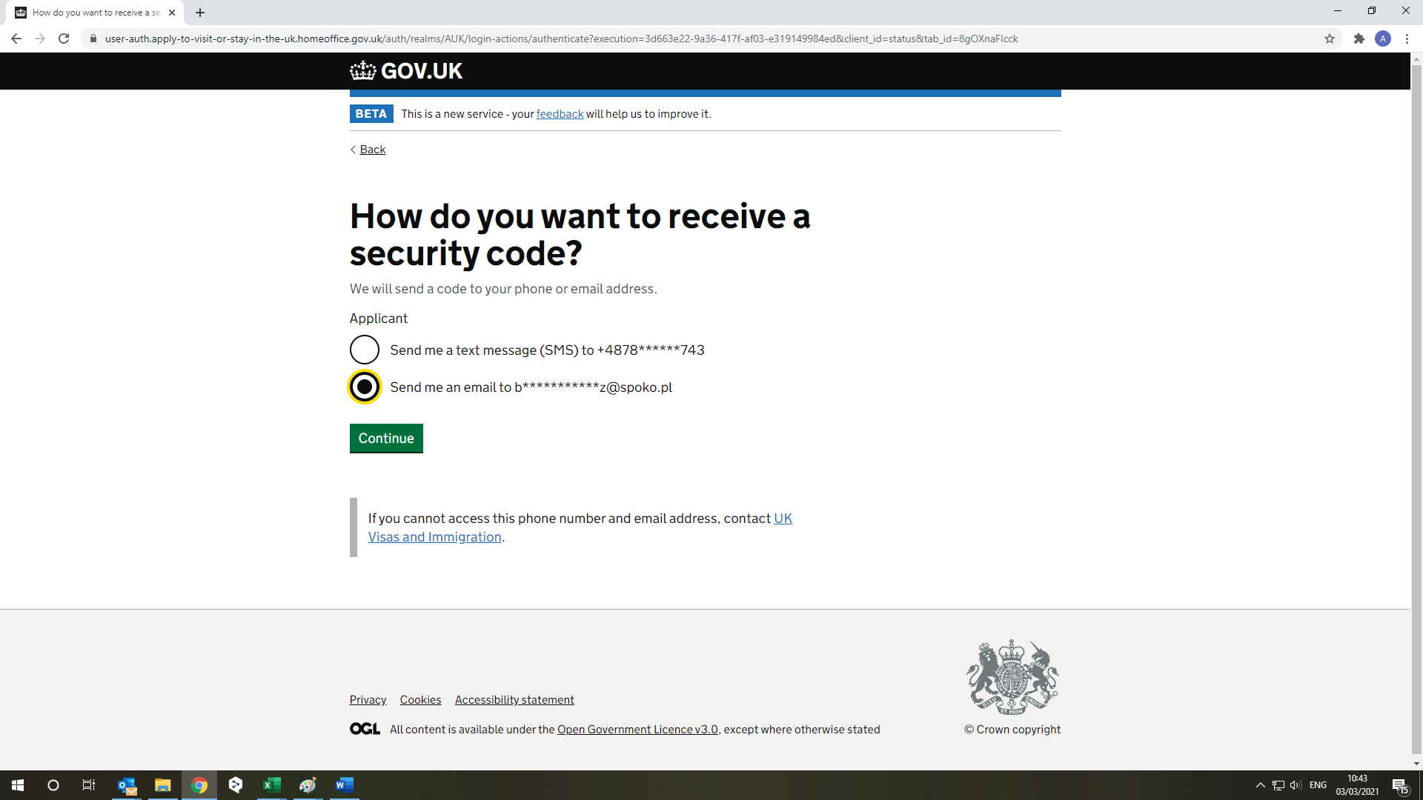

Choose what suits you the best

[Anthonysample@gmail.com](mailto:Anthonysample@gmail.com)

+44 165388244

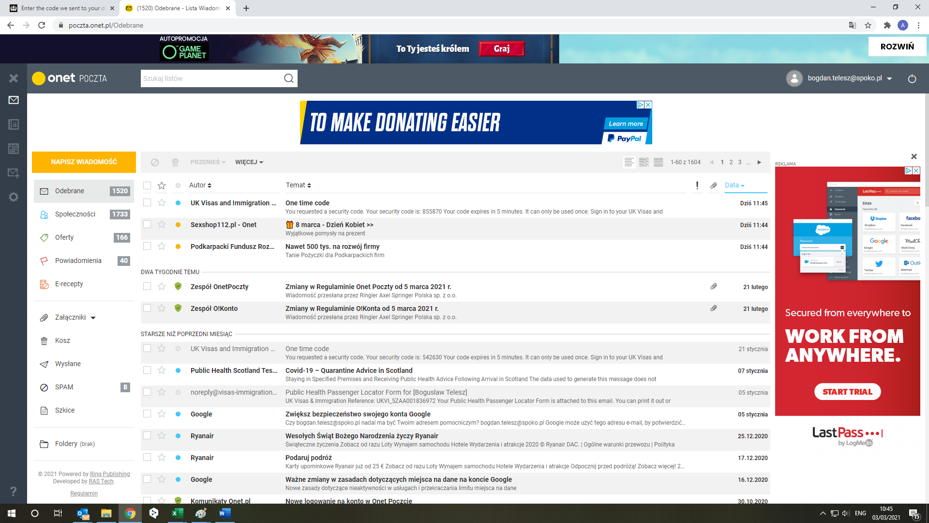

Find your code.

[Anthonysample@gmail.com](mailto:Anthonysample@gmail.com)

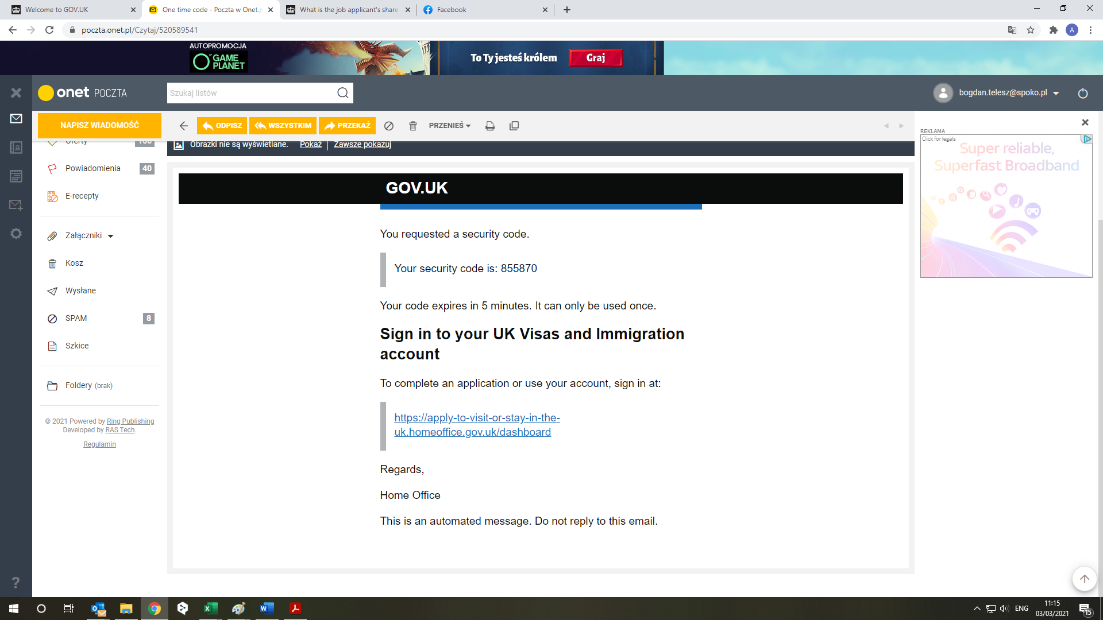

[Anthonysample@gmail.com](mailto:Anthonysample@gmail.com)

Type in code in here from your last email.

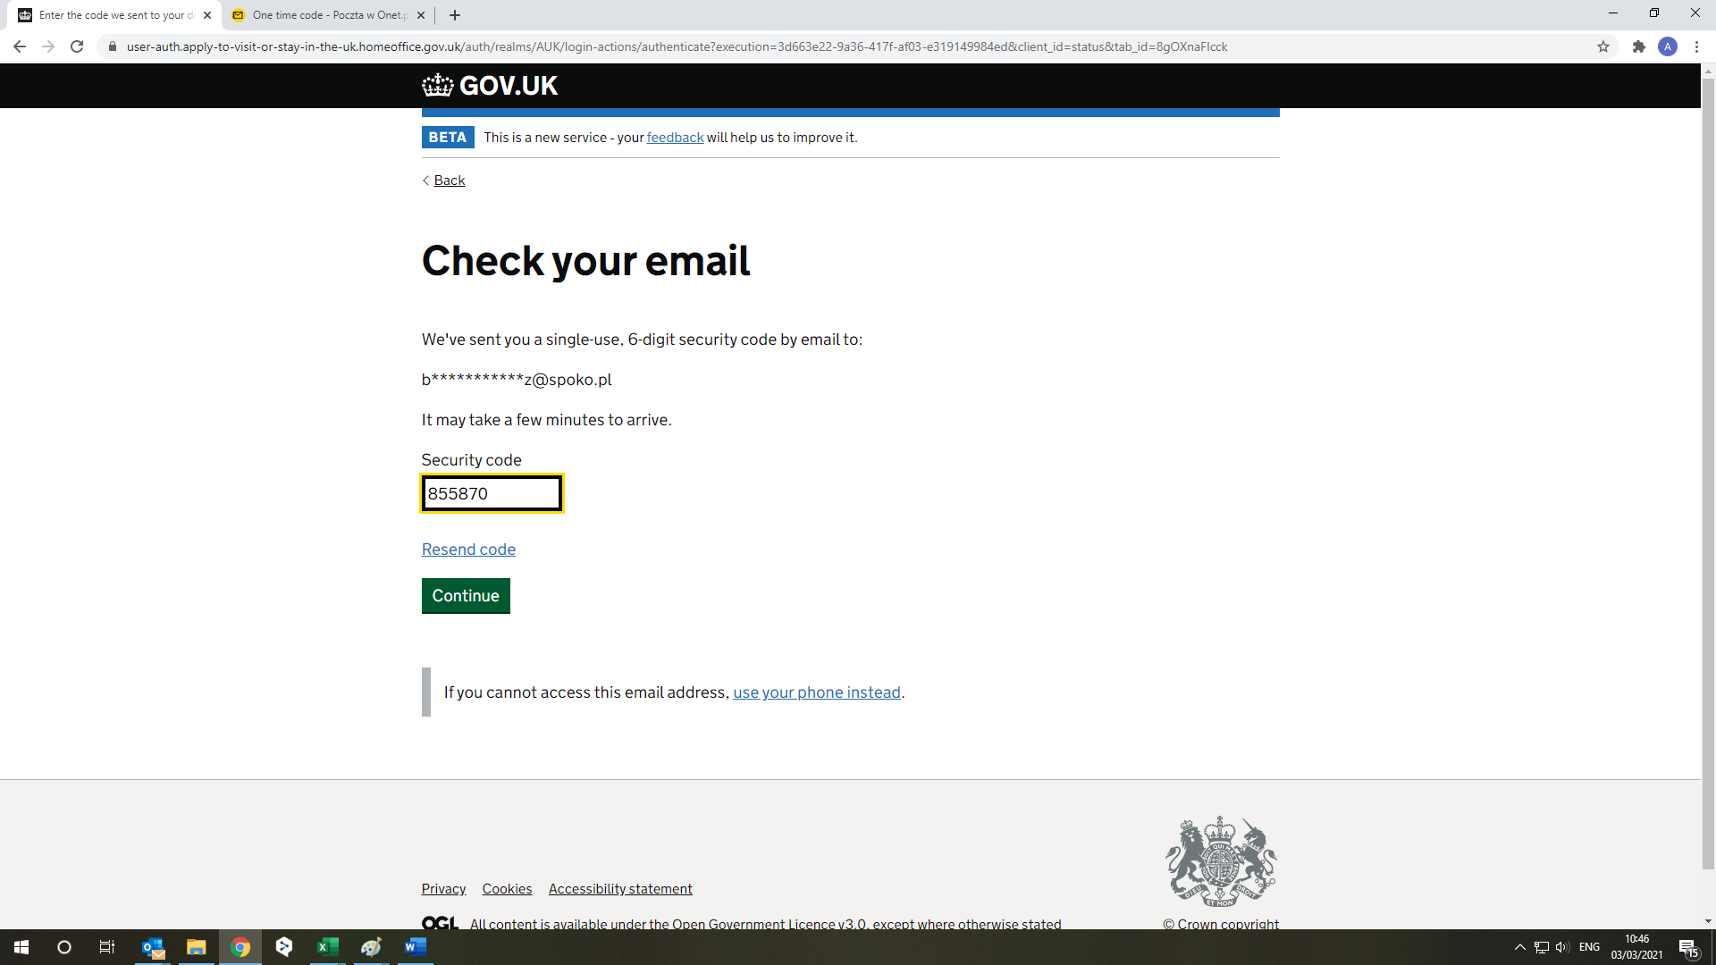

Type in code in here from your last email.

[Anthonysample@gmail.com](mailto:Anthonysample@gmail.com)

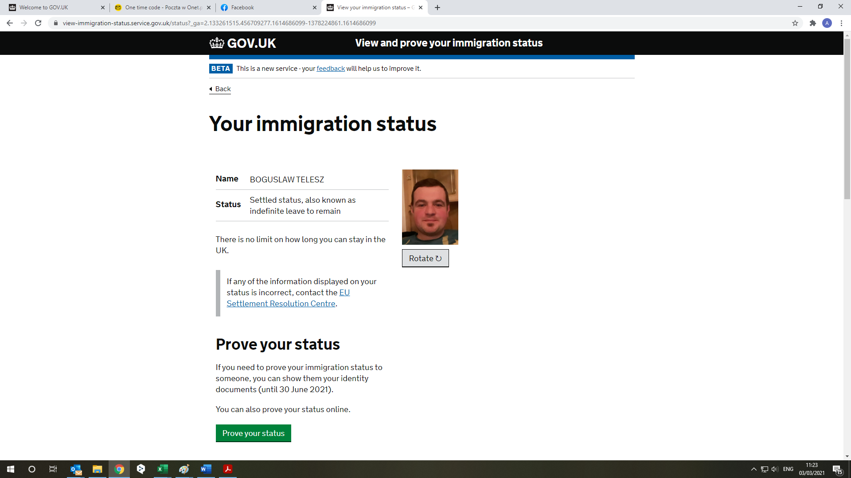

Click this button

Anthony Sample

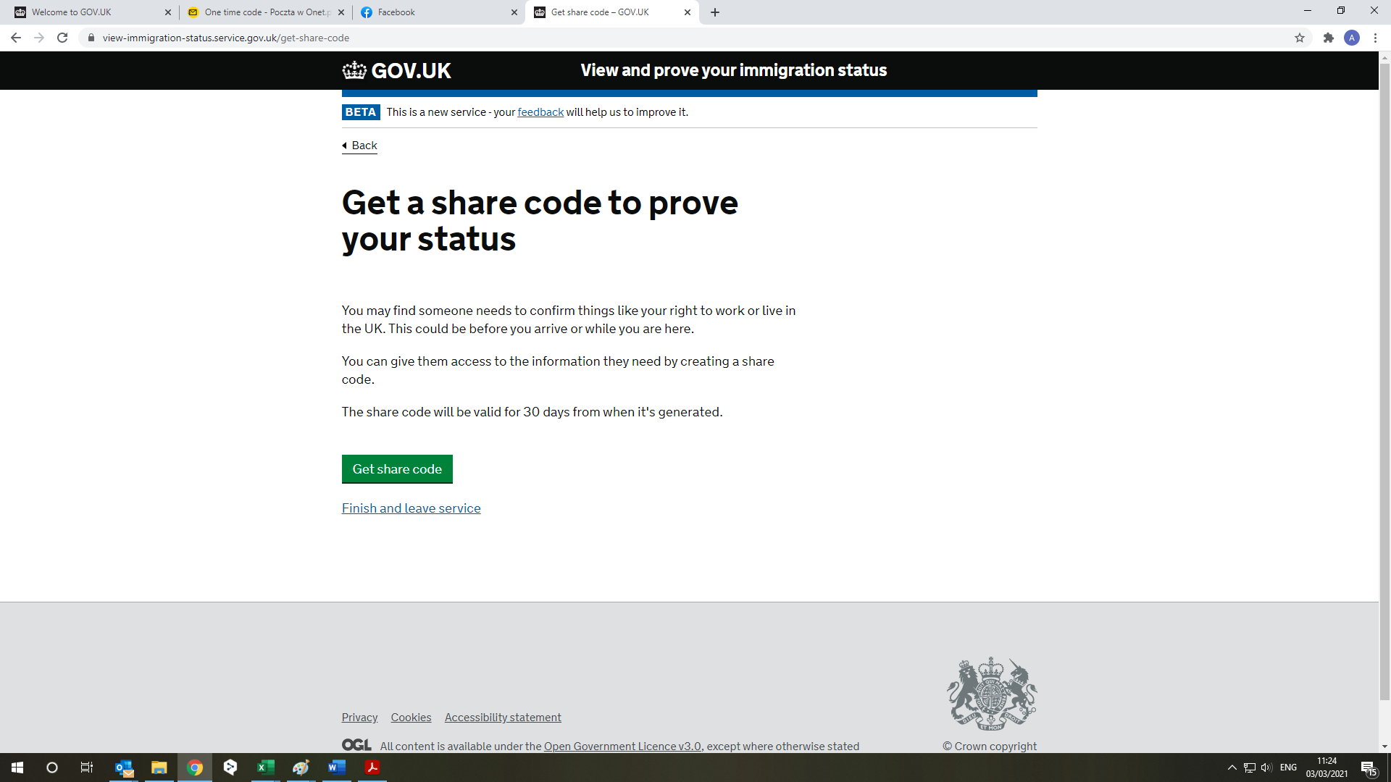

Clink on that

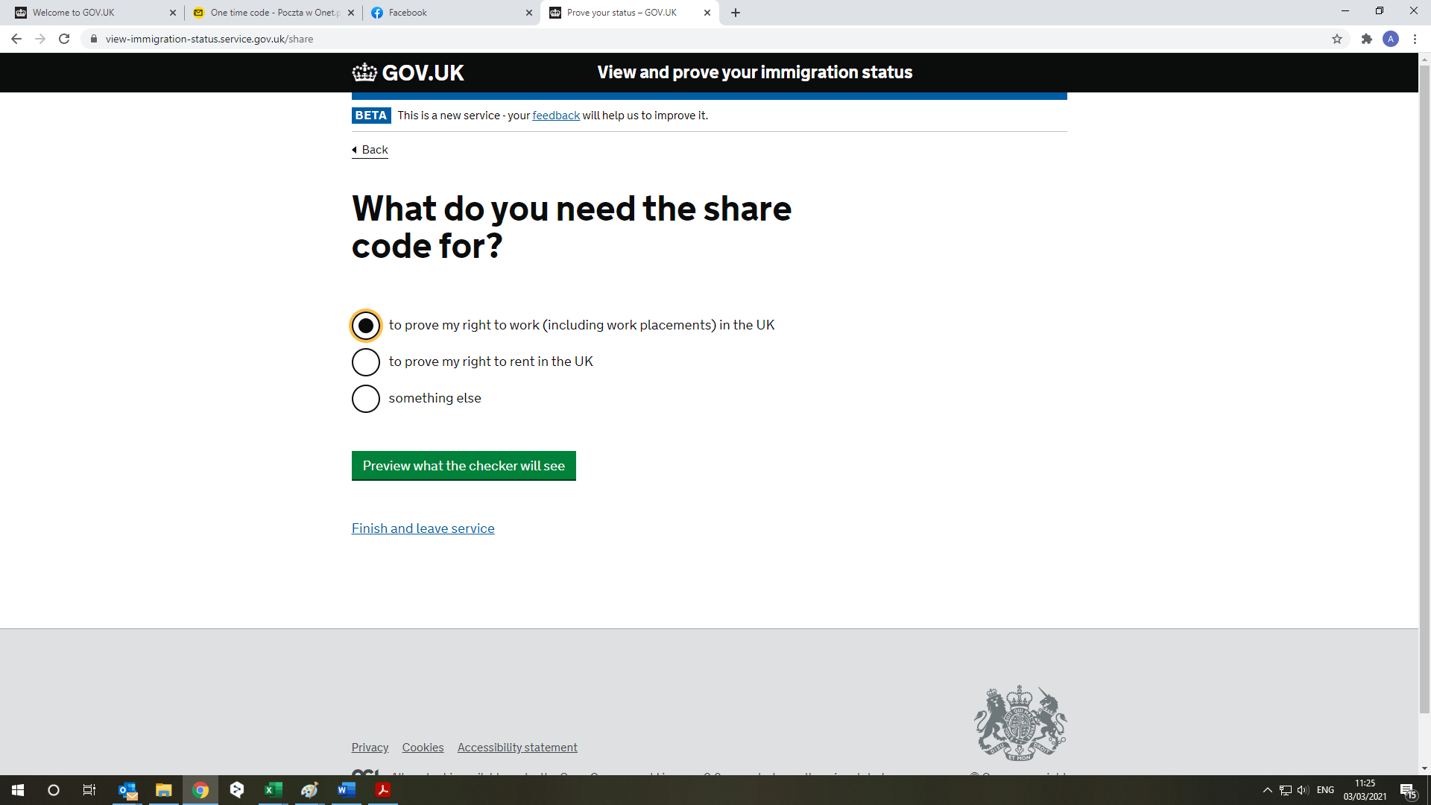

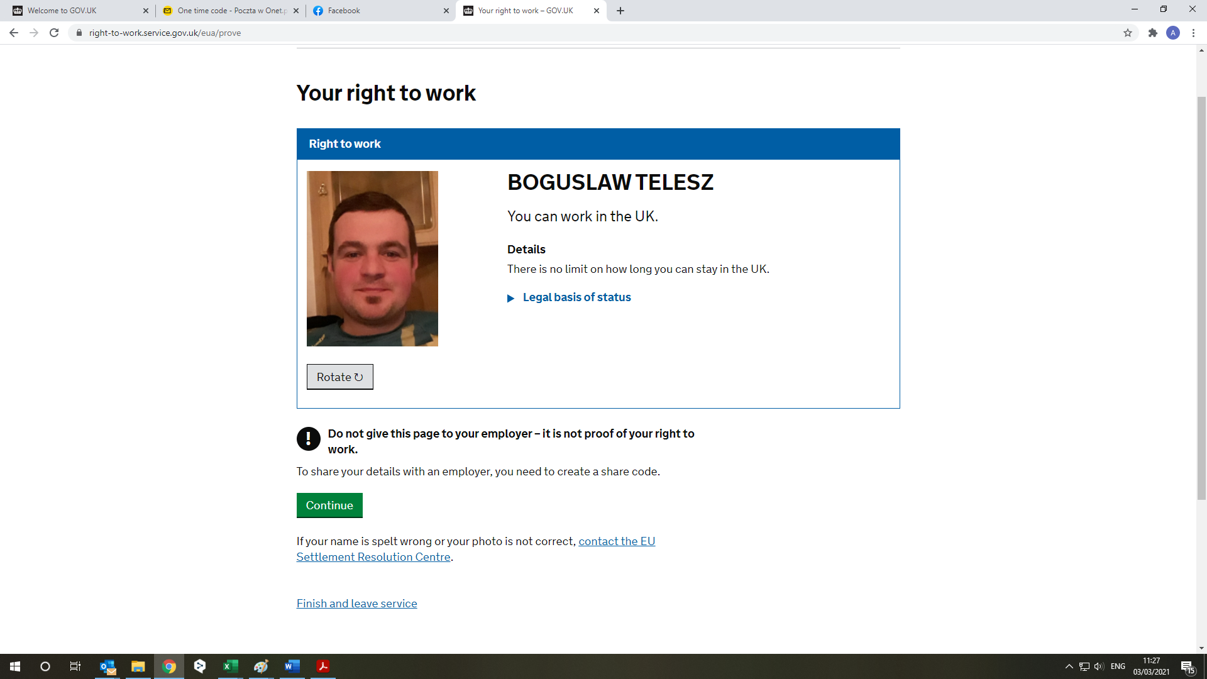

Click on that green button.

Anthony Sample

