**MAINS OF ERROL/ W GLEN LTD**

Mains of Errol is owned by Karen Arnot

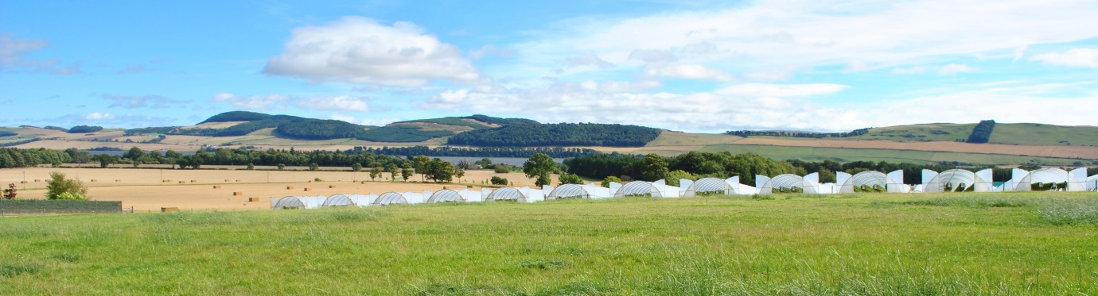

* 43 acres Strawberries
* All table tops
* 213 acres Grain



* 3 Full time staff
* 36 Packhouse Workers
* 190 Seasonal Worker

**WORK**

* Strawberry picking
* Leaves and flowers, runner cutting, weeding
* Husbandry work and all plant care tasks
* Planting
* 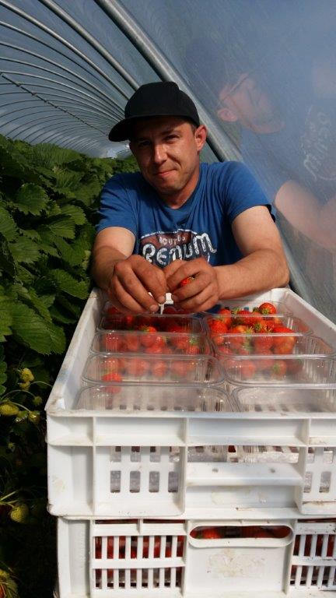Tunnel Building
* General Farm work
* Packhouse work

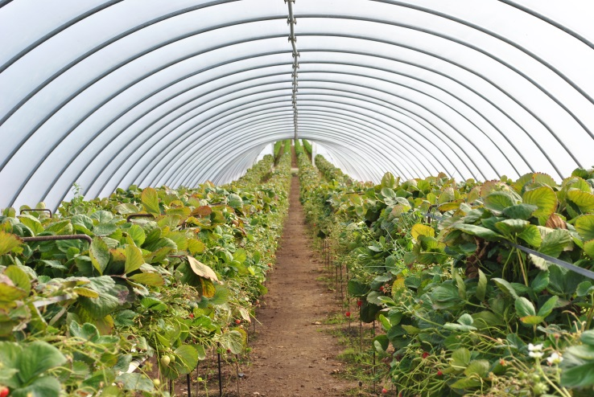

**TRAINING**

* All workers will be trained by staff who can communicate in English/Polish/Russian/Lithuanian/ Latvian/Bulgarian/Romanian.

**WORK SEASON**

Season starts in late May as one crop is finishing the other is reaching peak and this continues until October

**WAGES**

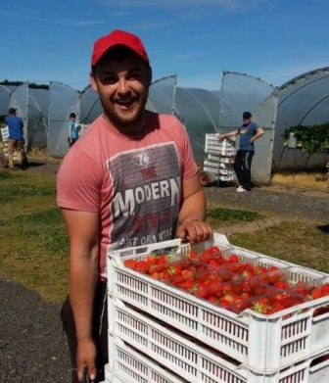

* Weekly pay by bank transfer
  + If you don’t have a UK bank account,  
    we’ll arrange it for you

National minimum wage

https://www.gov.scot/publications/agricultural-wages-scotland-twenty-seventh-edition-guide-workers-employers/pages/2/

* Holiday pay entitlement

On the farm we use a bonus system which means, the more you pick the more you earn. If you pick more than the minimum standard per hour you get bonus.

High earnings: £400-£450 / week

Average earnings: £335-400 / week

**MINIMUM STANDARD**

* The minimum standard we expect on our farm following training is 30 kilos per hour based on picking in to a 400-gram punnet, this equates to approximately 7.5 trays per hour.
* If somebody does not meet the minimum standard we will retrain them, try them with other work, but if after 7 days they do not meet the required standard they must understand it becomes uneconomical for us to continue their employment.
* Training and techniques will be given at all times

**HOURS OF WORK**

* Starting times vary according to crop and weather
  + Typical start time: 6.00am
  + Typical finish time: 2:30pm
  + 60 minutes break throughout the day (unpaid)
  + Some days we start early but this means we finish early
* Average 6-8 hour per day with a minimum of 32 hours per week
* Days off vary to suit crop

**ACCOMMODATION**

* Basic accommodation in static caravans
  + Up to 6 workers / caravan
* In each caravan:
  + Living room (seating, heater, eating area)
  + Kitchen (cooker, fridge, pots and pans, plates and cutlery)
  + Bathroom (toilet, sink, shower)
  + 2-3 Bedrooms (bedding is not supplied for hygiene reasons)

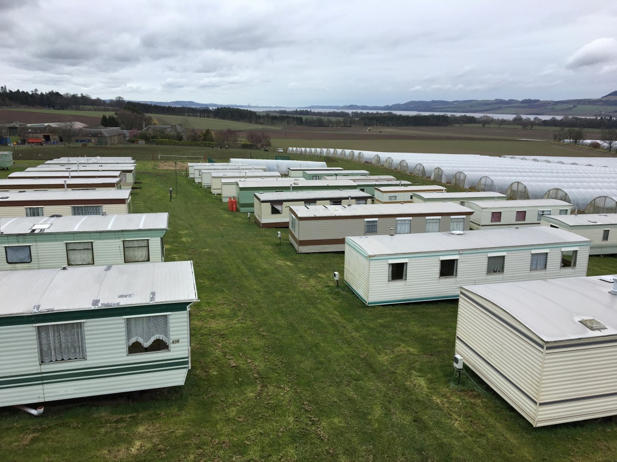

The farm complies with all necessary regulations required for accommodation of this type

Each caravan is fitted with smoke detector and carbon monoxide detector (tested weekly)

All caravans have safety certificates for gas and electric

**FACILITIES**

On site:

* Washing area with washing machines and chest freezers
* Games room – pool table, table tennis, etc.
* 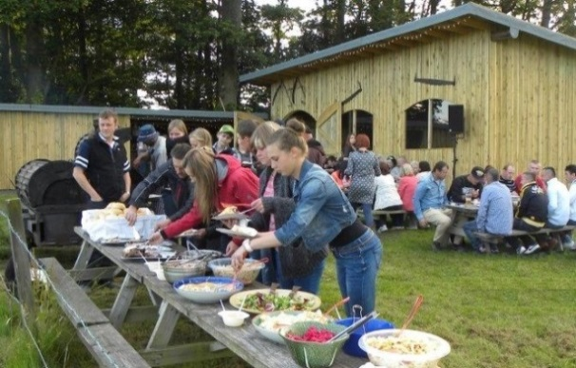BBQ area
* Football / Volleyball pitch

In Perth / Errol:





* Library (free internet access)
* Swimming pool
* Leisure Centre
* Gym
* Perth College
* Shopping Centre
* Lidl, Tesco, Asda
* Car boot sale
* Museums
* Scone Palace
* Pubs and Restaurants
* Train / bus station

**COSTS**

National Insurance:

* This is a government requirement. It helps to cover basic medical treatment while living in the UK. We will help with obtaining N.I. number. National insurance is deducted from your weekly pay at approximately 12% of everything earned over £242. This does not apply to anyone under 21.

Tax:

Tax is payable at approx. 20% of your earnings – government requirement. For tax free allowance check

[Rates and thresholds for employers 2023 to 2024 - GOV.UK (www.gov.uk)](https://www.gov.uk/guidance/rates-and-thresholds-for-employers-2023-to-2024)

Accommodation (facility fee):

* Charge changes every year on the 1st of April
* For 2023 the charge is £50.00 per person/ per week /deducted from payslip

We will charge you for electricity and gas.

**OUR CERTIFICATES AND AUDITS**

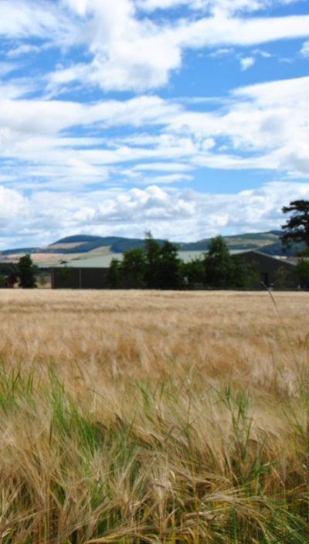

* Yearly BRC Audit
* Retailers’ Audits
* Ethical Audit
* Public Liability Insurance
* First Aid Certificates
* SFQC Certificate of Conformity
* NSF Certificate of Conformity
* TESCO Certificate of Conformity
* Red Tractor Licence Certificate

**ACHIEVEMENTS**



Mains of Errol Farm was awarded

* Packhouse of the year 2009
* Packhouse of the year 2015
* Best PQD working with ASDA–growers reward 2010
* Member of Angus Grower & Angus Soft Fruit

**TRAVEL**

* You pay for your own travel
* 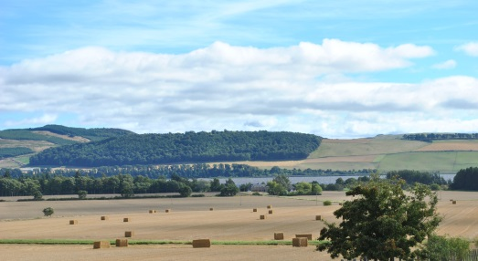If you come by car please take documents

How to get here:

* Fly to:
  + Edinburgh Airport
  + Glasgow Airport
  + Glasgow Prestwick Airport
* From the airport get a train / bus to Perth
* From Perth take the bus 16 to Port Allen
  + Ask the bus driver to tell you when to get off.

**THINGS TO BRING**

* Most importantly Yourself
* Sense of humour and a positive attitude
* Passport or ID card
* Driving licence / any other documents / certificates
* Money for the first week – £150.00 approximately
* Sleeping bag, blanket or duvet (we do not supply bedding)
* Towels
* Warm clothing and good footwear

**ARRIVAL**

* Inform office about your arrival or send text message
* Documents will be checked
* Paperwork completed
* Accommodation arranged
* Tour of farm and facilities
* Health and Safety explained
* Start day and time arranged
* 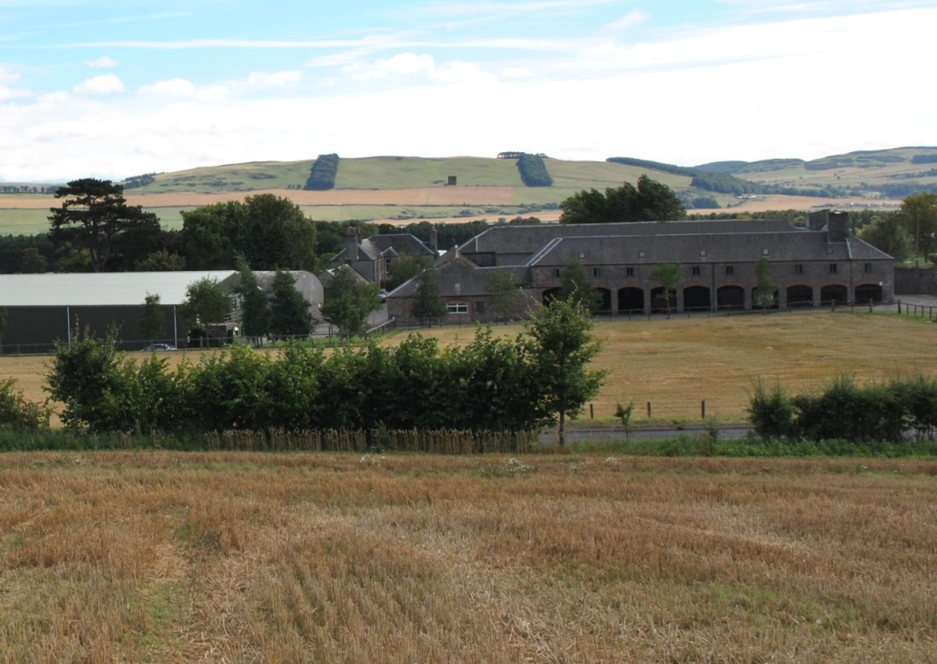Questions answered

**CONTACT**

* Address:

W GLEN LTD

MAINS OF ERROL

ERROL

PERTHSHIRE

PH2 7TE

SCOTLAND

* E-mail:

[jobs@wglenandson.farm](mailto:jobs@wglenandson.farm)

personnel@wglenandson.farm

* Phone:

[00](mailto:xxx@wglenandson.co.uk) 44 1821 642 878

* Website:

www.wglenandson.farm

If you are interested in working with us please fill in the online application form on our website or follow the facebook link.